This specification defines the functionality of the postprocessor your company will order. It is needed for the final acceptance and the customer must sign this document with an authorized signature.

Please return this document to us and give us additional information with further information for

- Scheme of machine with definition of axes to be programmed
- List of G- and M-codes
- Sample program with program header, program trailer, tool change and all relevant commands needed. Please comment special commands and cycles.

Customer data:

Company: _______________________________________________________

Street: _______________________________________________________

Postal Code: _________ Location:____________________________________

Contact 1: Mr. / Mrs.: ___________________________________________

Telephone 1: ______________________________________________________

E-Mail 1: ______________________________________________________

Contact 2: Mr. / Mrs.: ___________________________________________

Telephone 2: ______________________________________________________

E-Mail 2: ______________________________________________________

Date: ______________ / Signature:____________________________________

Unique Machine/-control/vendor names:
Machine: (e.g.: CTX420) ____________________________________
Manufacturer: (e.g.: DMG) ____________________________________
Controller: (e.g.: S840D) ____________________________________

Machining type:
Turning
Milling
Drilling
Other: ____________________________________________

Configuration of axes:
Linear axis (e.g. Z): ____________________
Rotation axis (e.g. C): ____________________

Linear axis (e.g. X): ____________________
Rotation axis (e.g. A): ____________________

Linear axis (e.g. Y): ____________________
Rotation axis: (e.g. B): ____________________

Coordinate axis for the spindle axis (e.g. Z)

_________________________________________________________________________

Turning mode

Turrets, tool holders (channels)

Turret 1:
Active Tools:
Yes
No
Number of controlled axis: ____
Name of axis: X Y Z A B C S __ __

Turret 2:
Active Tools:
Yes
No
Number of controlled axis: ____
Name of axis: X Y Z A B C S __ __

Turret 3:
Active Tools:
Yes
No
Number of controlled axis: ____
Name of axis: X Y Z A B C S __ __

For additional turrets, tool holders, copy above and fill out block
Spindles:

Spindle 1:
Number of controlled axis: ____
Name of axis: X Y Z A B C S __ __

Spindle 2:
Number of controlled axis: ____
Name of axis: X Y Z A B C S __ __

Spindle 3:
Number of controlled axis: ____
Name of axis: X Y Z A B C S __ __
For additional spindles, copy above and fill out block
The axes naming for turrets, tool holder, spindles need to be accurately defined, e.g. X1, Y2, Z2, S3, etc.)

Additional Axis (stationary support, tailstock, …)

Additional axis 1: _________________________________________

Name of axis: : X Y Z A B C __ __
M / G function _________

Additional axis 2: _________________________________________

Name of axis: : X Y Z A B C __ __
M / G function _________

Additional axis 3: _________________________________________

Name of axis: : X Y Z A B C __ __
M / G function _________

Additional axis 4: _________________________________________

Name of axis: : X Y Z A B C __ __
M / G function _________

Active tools

Axis direction 1: _________________________________________

Name of axis: : X Y Z A B C __ __
M / G function _________

Axis direction 2: _________________________________________

Name of axis: : X Y Z A B C __ __
M / G function _________

Milling mode

Axis:

Number of controlled axis: _______________________________

Description of axis:
Name of axis: X Y Z A B C __ __

Horizontal / vertical head:
Yes
No
When horizontal / vertical head is used, is it switched automatically? (e.g. M54)
Yes
No
If “yes“, which code to output:
Horizontal M: _____
Vertical M: _____
If “no“, what is standard:
Horizontal
Vertikal

Axis mode:
Positioning
Simultaneous

When positioning, what Code is used?
Cycle 19 / Cycle 800 / G7 / …: ________________________________

When simultaneous, what Code is used?
Traori / M128 / …: ________________________________

Is the code for rotation axis customized for your machine and tested through you or the machine manufacturer?
Yes
No
Rotation axes available?
Yes
No

When rotation axes are available, where are these axis mounted (head or table)?
What are the minimum/maximum limits?
(e.g. A is turning around Y within range of - 30° to + 45°)?
A Head Table ___________
B Head Table ___________
C Head Table ___________
Other:_________________________________________

Polar coordinate output needed?
Yes
No
Cylindrical mode needed
Yes
No

For 5-axis machines only: Are the axis orthogonal (perpendicular)?
Yes
No

Distance of turning axis to center, if needed:

________________________________________________________________________________________________

________________________________________________________________________________________________
Kinematics:
Please insert machine kinematics view/scheme, e.g. :

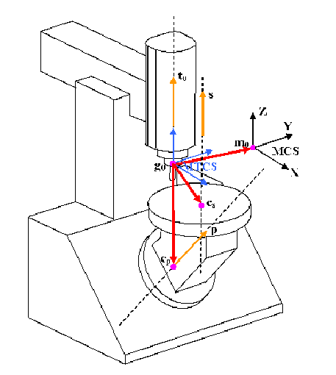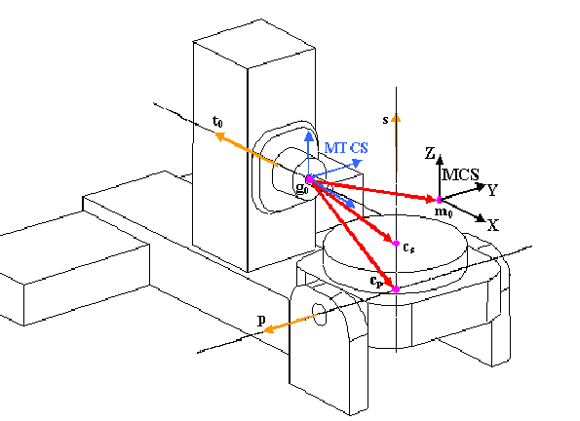

Working planes:

G17 (+XY)
–G17 (-XY)
G18 (XZ)
–G18 (-XZ)
G19 (YZ)
–G19 (-YZ)

Tool change:
Automatic Code (e.g. M6): _____________________
Manual Code (e.g. M66): _____________________

Tool preselection:
Yes Code: (e.g. M66): ___________________________
No

Pallet change/loading robot:
No
Yes code output only (e.g. M60): ___________________________
Yes separate list/file output needed – attach list/file with description

Drilling mode

Used standard drilling cycles:

Drilling
Drilling with delay
Breakchip drilling
Peck drilling
Tapping
Reaming
Other drilling cycle (please name and describe, sample output)
_____________________________________________
_____________________________________________
_____________________________________________

Description of working area: __________________________________________________________
_____________________________________________________
_____________________________________________________
_____________________________________________________
_____________________________________________________
_____________________________________________________

The scope of features and functions correspond with the possibilities of the NX-CAM Programming system.

NX standard-postprocessors include the following functionalities:

Linear and rotational movements (rapid and with feeds/speeds) and 5 axes positioning
Simultaneous movements
Tool change
Retract moves

G - functions:
Delay (e.g. G04)
Toolpath offset (e.g. G41,G42)
Standard drilling cycles (e.g. G81)
Origin definition (e.g. G54–G59)
Positioning absolute or incremental (e.g. G90/G91)

M - functions:
Programmed stop (e.g. M00)
Spindle direction, Spindle stop (e.g. M03,M04,M05)
Toolchange (e.g. M06 T1)
Coolant code normal or through tool (e.g. M07,M08)
Axis clamp or unclamp as M-function

Requirements for other NON NX standard functionalities:

On Machine Probing:
Yes
No

If yes, please select option and attach sample program
Option UDE
Programming through positioning moves and cycle definition with menue
input (UserDefinedEvent). No tool path simulation
Option UserCycle
Programming through cycle operations with cycle parameter
input and tool path simulation
Option Renishaw Productivity+
Programming through the integrated module
Productivity Plus from Renishaw
Special Renishaw cycles with tool path simulation
Option Blum Probing Cycles (BL9700)
Programming through Pt2Pt and UDE output, no tool path simulation
With machine simulation
Other probing cycle programming/output
Please attach separate specification and meaningful program sample

Tool calibration:
Yes
No
If yes, please select option and attach sample program
Blum cycles
Programming through positioning moves and cycle definition with menue
input (UserDefinedEvent). No tool path simulation
Other cycleprogramming/-output
Please attach separate specification or meaningful program sample

Angled heads
Yes
No

If yes, please select option and attach sample program
1. ___________________________________________
2. ___________________________________________
3. ___________________________________________
4. ___________________________________________
5. ___________________________________________
6. ___________________________________________
7. ___________________________________________

Simultaneous Turning 3-Axis:
Yes
No

If yes, please select option and attach sample program..
Customer please check function on machine.
1. ___________________________________________

Subprogramming:
Yes
No
When “yes”, please attach a demo program.

User- and special cycles:
Yes
No
When “yes”, please attach a sample program output
With cycle description

Additional output of processing time table:
Yes
No
If Yes, what requirements?
Availability of according machine parameters?
(Rapid feed values, M-Code times, etc.)
1. ___________________________________________
2. ___________________________________________
3. ___________________________________________

Output of additional lists:
Yes (e.g. list of origins, toollist …)
No
When “yes”, which lists are needed? Attach sample list
1. ___________________________________________
2. ___________________________________________
3. ___________________________________________
4. ___________________________________________
5. ___________________________________________
6. ___________________________________________
7. ___________________________________________
Please attach a sample

Other requirements:
_______________________________________________________________________
_______________________________________________________________________
_______________________________________________________________________
_______________________________________________________________________
_______________________________________________________________________
_______________________________________________________________________

NX Version:
NX7
NX8
NX9
NX10
NX11
NX12
______________________________________________

Operating System:
Windows XP (32 bit)
Windows XP (64 bit)
Windows 7 (32 bit)
Windows 7 (64 bit)
Windows 8/8.1 (64 bit)
Windows 10 (64 bit)
_______________________________________________

